Software Requirements Specification
for
SRS generation
Prepared by Smit Gandhi
Organization: My personal
Date Created: 02/11/2026

Table of Contents

[Note: The Table of Contents will be automatically generated when you open this document in Microsoft Word. If it doesn't appear, right-click and select 'Update Field']

1. Introduction

1.1 Purpose
The purpose of SRS generation is to solve Generate SRS based on user requirements as defined in the user inputs.

1.2 Intended Audience
This document is intended for:
- Admin

1.3 Project Scope

Included in scope:
- srs generation

Excluded from scope:
- hardware manufacturing
- third-party marketing

1.4 Document Conventions
- Standard IEEE formatting
- Bold text for UI elements

1.5 References
- GDPR: General Data Protection Regulation

2. Overall Description

2.1 Product Perspective
A standalone AI/ML System for the Other sector, as specified in the project identity.

2.2 Product Features
- srs generation

2.3 User Classes and Characteristics

Admin
- Tech-savvy
- Frequent use

2.4 Operating Environment
- Python backend
- Any database
- Any deployment

2.5 Design and Implementation Constraints
- GDPR compliance
- Python backend

2.6 User Documentation
- User Manual

2.7 Assumptions and Dependencies

Assumptions:
- User provides requirements

Dependencies:
- Python runtime
- GDPR compliance

3. System Features

3.1 SRS Generation
Description: Generates SRS based on user requirements

Stimulus/Response Sequences:
Stimulus: User provides requirements
Response: System generates SRS document

Functional Requirements:
- The system shall accept user requirements as input.
- The system shall generate a SRS document based on the user requirements.
- The system shall ensure the generated SRS document is in a high-level format.

4. External Interface Requirements

4.1 User Interfaces
The system provides a web-based interface for Admin users to input requirements and generate SRS documents. The interface is built using a responsive design with React and TypeScript, supporting modern web browsers.

User Interface Architecture:
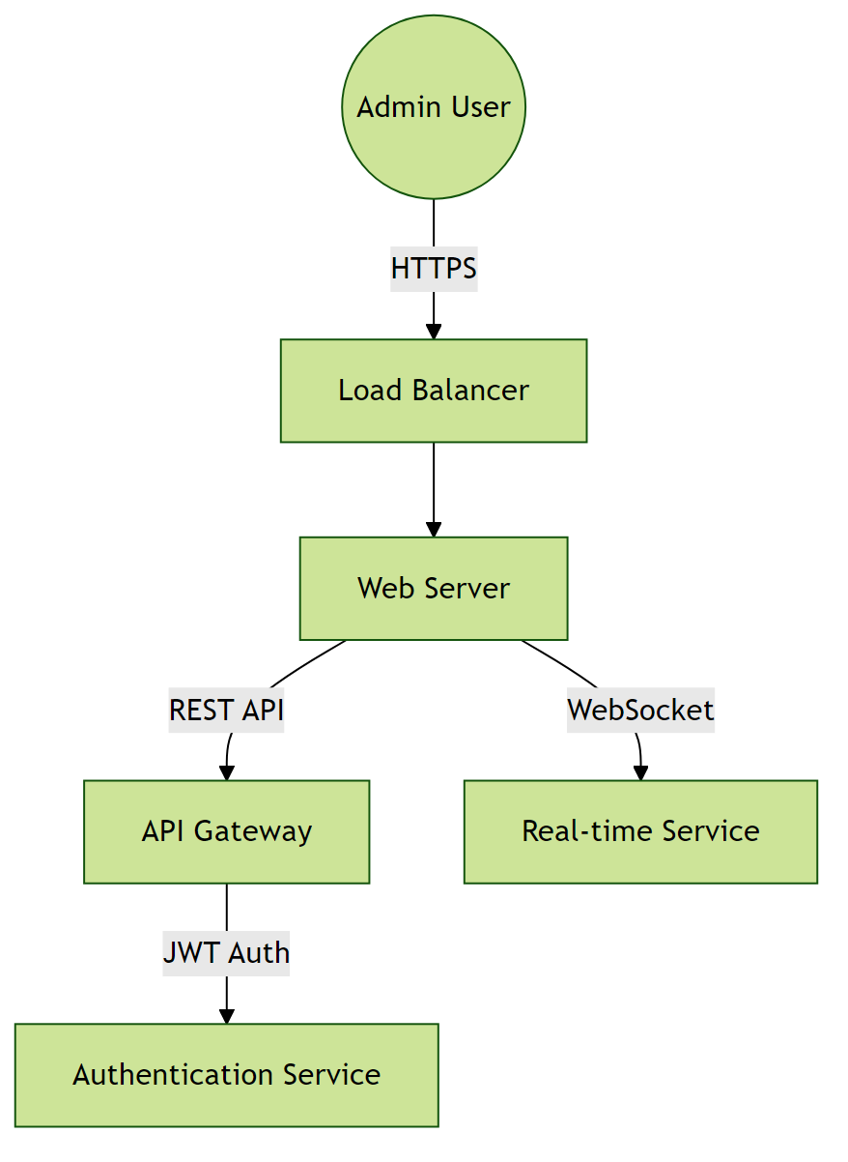

4.2 Hardware Interfaces
The system operates in a cloud-native environment with no direct hardware integrations. All infrastructure is virtualized and managed through containerization.

Hardware Interface Architecture:
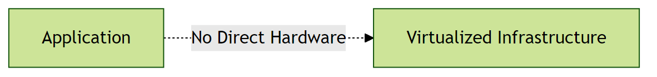

4.3 Software Interfaces
The system uses Python as the preferred backend language. It integrates with various software components, including databases and AI/ML libraries.

Software Interface Architecture:
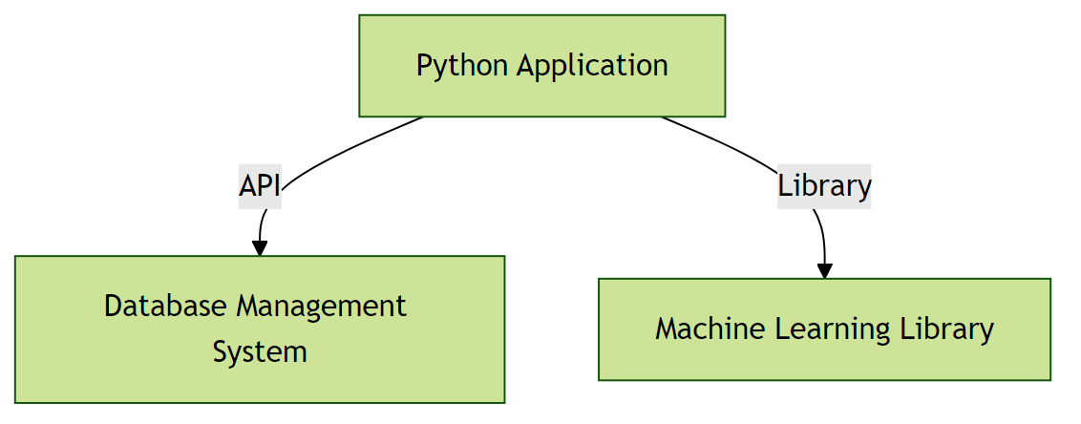

4.4 Communication Interfaces
The system communicates using RESTful APIs over HTTPS. It also uses WebSockets for real-time communication.

Communication Interface Architecture:
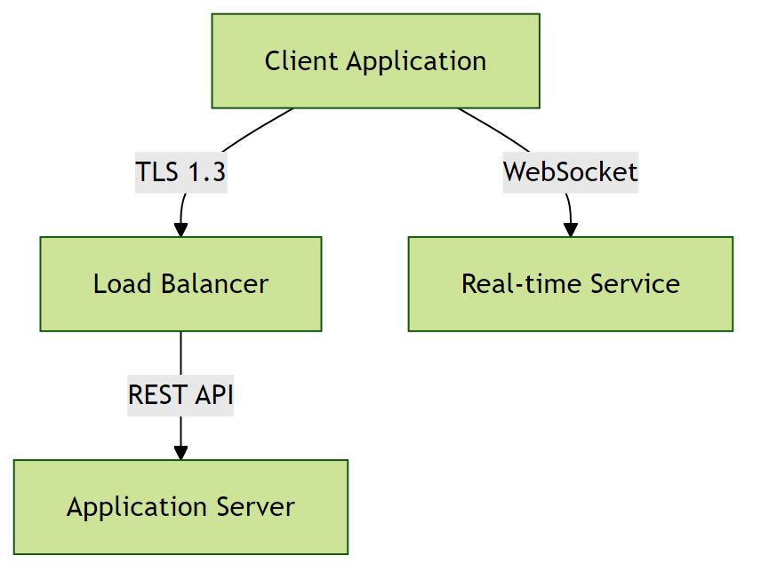

5. Non-Functional Requirements

5.1 Performance Requirements
- The system shall support less than 100 concurrent users without performance degradation.
Rationale: To accommodate expected peak traffic.
- The system shall respond to user requests within a reasonable time under normal load.
Rationale: To ensure a responsive user experience.

5.2 Safety Requirements

5.3 Security Requirements
- The system shall handle sensitive data in accordance with GDPR compliance requirements.
Rationale: To protect sensitive user information.
- The system shall implement measures to prevent unauthorized access to sensitive data.
Rationale: To ensure data security and integrity.

5.4 Quality Attributes
- The application must achieve high availability.
Rationale: To ensure reliability for users.
- The system shall be maintainable with modular architecture.
Rationale: To enable efficient updates and reduce long-term maintenance costs.

6. Glossary

6.1 Technical Terms
AI/ML System: Artificial Intelligence/Machine Learning System - a system that uses AI/ML techniques to perform tasks.
GDPR: General Data Protection Regulation - a regulation in EU law on data protection and privacy.
Python: A high-level, interpreted programming language used for developing the backend of the system.

6.2 Acronyms and Abbreviations
SRS: Software Requirements Specification - a document that describes the requirements of a software system.
API: Application Programming Interface - a set of protocols and tools for building software applications.

6.3 System Components
Authentication Service: Component responsible for verifying user credentials and managing access tokens.
Database Layer: Persistent storage layer managing data operations and ensuring data integrity.

6.4 Technologies
Cloud Service Providers: Third-party services that provide cloud-based infrastructure for deployment and scaling.
Python Backend: The use of Python as the backend programming language for the system.

6.5 Performance Metrics
Concurrent Users: Number of users actively using the system simultaneously without performance degradation.
Response Time: Time elapsed between a user request and the system's response.

6.6 Security Terms
Authentication: Process of verifying the identity of a user or system.
Authorization: Process of determining whether a user has access to a particular resource or functionality.
Encryption: Process of converting plaintext data into unreadable ciphertext to protect it from unauthorized access.

6.7 Quality Attributes
Reliability: Ability of the system to perform its required functions under normal operating conditions.
Scalability: Ability of the system to handle increased load or demand without decreasing performance.
Maintainability: Ease with which the system can be maintained, updated, or modified.

7. Assumptions

Assumption 1:
The user will provide requirements for SRS generation.
Impact: If the user does not provide requirements, the system will not be able to generate the SRS document.

Assumption 2:
The system will be used by less than 100 concurrent users.
Impact: If the system is used by more than 100 concurrent users, performance degradation may occur.

Assumption 3:
The system will handle sensitive data in accordance with GDPR compliance requirements.
Impact: If the system does not handle sensitive data in accordance with GDPR compliance requirements, it may lead to data breaches and legal issues.

Assumption 4:
The Python backend and runtime environment will be available and compatible.
Impact: If the Python backend and runtime environment are not available or compatible, the system may not function properly.

Assumption 5:
The user has basic computer literacy and familiarity with web-based applications.
Impact: If the user lacks basic digital skills, additional training programs and simplified UI/UX may be required.

Assumption 6:
Regulatory requirements for data privacy (GDPR) will remain stable during development.
Impact: Changes in data privacy regulations could necessitate significant architectural changes, additional compliance features, and potential project delays.

